Day 1 – Assignment 2

* Draw your home network topology and explain how you are accessing the RPS Lab environment.
* 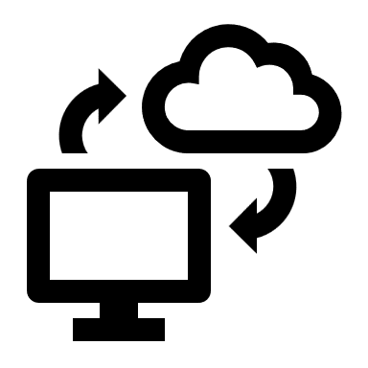Home Network Topology

RPS Cloud Lab

Internet

ISP Modem / Router

Home Network Topology

For Accessing RPS Cloud Environment

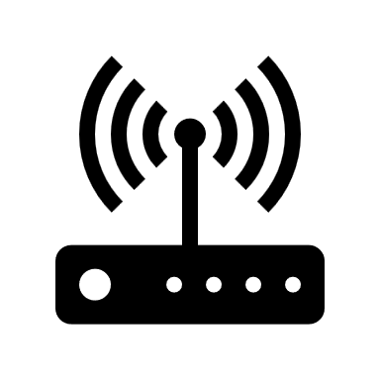

Laptop